1. Which were built in such a way that humans supply the inputs and interpret the outputs?
a) Agents
b) AI system
c) Sensor
d) Actuators
2. The test conducted finds out whether a machine's ability to think is equivalent to, or indistinguishable from, that of a human, known as
a. Artificial Intelligence
b. Turing Test
c. Eliza
d. None of these
3. What type of AI system is able to perform a dedicated task with intelligence__________?
a) General AI
b) Narrow AI
c) Strong AI
d) All of these
4) we have to design an Artificial Intelligence system, which having short period of time and less storage system to store past experience, in which category this AI system falls
a. Reactive Memory
b. Limited Memory Type 2
c. Theory of Mind
d. none of these
5. When we have to design an intelligent agents, what instruments are required for perceiving and acting upon the environments?
a. sensors
b. actuators
c. perceivers
d. both a and b

6. An agent which is based on current situations and do not perceives from past experience, then the agent is defined as
a. Goal-based agent
b. utility based agent
c. situation action rule
d. none of these.
7. A function that maps a state or sequence of states, by measuring an agent over the long run based on its happy or unhappy states_______________
a. simple reflex agent
b. Goal based agent
c. utility based agent
d. none of these
8. If an organization has developed an agent and they have to improve the performance of their agent. Then which approach used to improve their agent performance.
a. perceiving
b. learning
c. observing
d. none of these.
9. Which action sequences are required to accomplish the agent’s goal?
a) Search
b) Plan
c) Retrieve
d) Both Search & Plan
10. DFS agents will work in which state space
a. irreversible state spaces
b. reversible state spaces
c. searchable state spaces
d. all of these

11. A production system consists of
(a) A set of Rule
(b) A sequence of steps
(c) Directly getting solution
(d) both a and b

12. Which is the most straightforward method for designing an algorithm?
a) Best-first search
b) State-space search
c) Depth-first search
d) Hill-climbing search
13. Control strategy is a strategy by which we come to know which rule is to be applied next during the process of reaching for a solution to a problem and should always cause motion
a. True
b. False
14. The application of rule never prevents the later application of another rule that could also have been applied at the time that the first rule was selected, defined as
a. Monotonic Production System
b. Nonmonotonic production system
c. commutative production system
d. None.
15. Heuristic function of Best First Search is
a. f(n) != h(n)
b. f(n) < h(n)
c f(n) = h(n)
d. f(n) > h(n)
16. how can the performance of an agent improved if using heuristic search.
a. based on quality of heuristic function
b. by improving quality of the nodes
c. both a and b
d. none.

17. If an intelligent agent using Breadth First Search then what is the time complexity in reaching the desired goal state?.
a. O(b^d)
b. O(b-d)
c. O(b)
d. None of these
18. depth-first search is that it can get stuck going down the wrong path and should be avoided for search trees with large or infinite maximum depths.
a. True
b. False
19. In complete, local search algorithm goal finds if one exists, an optimal algorithm always finds a global minimum/maximum.
a. True
b. False
20. If we are using Hill Climbing algorithm then when this algorithm will terminate?
a) Stopping criterion met
b) Global Min/Max is achieved
c) No neighbor has higher value
d) All of the mentioned
21. What are the main limitation of hill-climbing search?
a) Terminates at local maximum & does not find optimum solution
b) Terminates at global maximum & does not find optimum solution
c) Does not find optimum solution & fail to find a solution
d) Fail to find a solution
22. What is the role of heuristic function?
a) A function to solve mathematical problems
b) A function which takes parameters of type string and returns an integer value
c) A function whose return type is nothing
d) A function that maps from problem state descriptions to measures of desirability
23. Which of the Following problems can be solved using Constraints Satisfaction Problems?
a) 8-Puzzle problem
b) 8-Queen problem
c) Map coloring problem
d) All of the mentioned

24. If we have to prepare a schedule for a class of student. What type of problem is this?
a) Search Problem
b) Backtrack Problem
c) Constraint Satisfaction Problem
d) Planning Problem
25. Make a big jump or randomly select a state far away from the current state. This is a possible solution to overcome issue in
a. A* Algorithm
b. Best First Search
c. Hill Climbing
d. Generate and test

26. What is the heuristic function of A* algorithm
a. f(n) = g(n) != h(n)
b. f(n) = g(n) < h(n)
c. f(n) = g(n) + h(n)
d. f(n) = h(n)
27. Using A* algorithm find the path with least cost (from a to z).
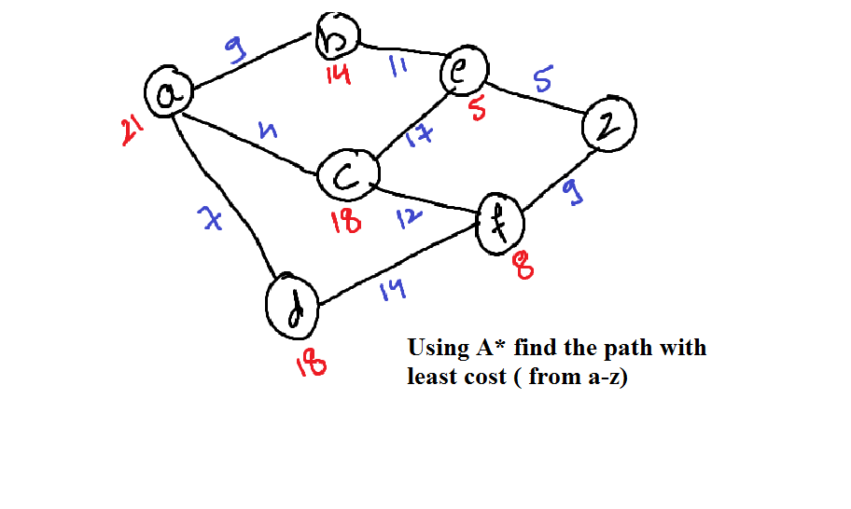
a. abez
b. abecfz
c. adfz
d. acez

28. Using Best First Search algorithm find the path with least cost (from a to z).

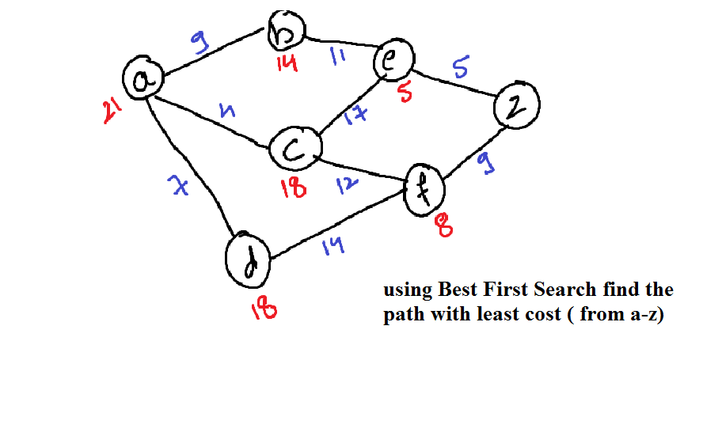
a. abez
b. acfz
c. adfz
d. acez

29. Which algorithm can be used in traversing graph and finding path?
a) A*
b) C*
c) D*
d) E*

30. if the next state of environment is completely determined by the current state and the actions selected by agents , then this type of agent environment is termed as
a. accessible
b. deterministic
c. episodic
d. static

31. Additional information or clue restricts the expansion of only promising nodes in search tree and guides the search in a specific direction towards the goal
a. True
b. False
32. A Heuristic function maps the desirability of a problem state from descriptive to quantitative numbers.
a. yes
b. no
33. Compute heuristic function (h(n)) of the given 8 puzzle problem
a. 12
b. 10
c. 11
d. 13
34. Which two heuristic approaches were used In DENDRAL AI?
a. hill climbing and Constraint satisfaction technique
b. A* and generate-test
c. plan-generate-test and Constraint satisfaction technique
d. none of these
35. Which heuristic technique is also termed as OR-graph?
a. A* algorithm
b. Hill climbing
c. both a and b
d. Best-First Search
36. Hill climbing is a variant of which heuristic approach
a. Best First Search
b. Generate-test
c. Depth First Search
d. both b and c.
37. How local maximum problem in Hill climbing can be overcome
a. Randomly select a state
b. move in several directions at once
c. Utilise the backtracking technique
d. None of these
38. The heuristic approach which computes distance of current node from start state and distance of current node to goal state.
a. Best First Search
b. A*
c. Hill Climbing
d. All of these
39. An heuristic algorithm is admissible heuristic if its heuristic function never________
a. underestimates the cost to reach the goal
b. overestimate the cost to reach the goal
c. both a and b
d. None of these
40. Which data structure is used in A* algorithm
a. stack
b. queue
c. priority queue
d. both b and c
41. If a blind search technique i.e depth first search used to solve an AI problem. Then which data structure is used
a. LIFO
b. FIFO
c. Hash Table
d. none of these
42. Artificial Intelligence (AI) is a way to make machines think and behave intelligently. Then these machines are controlled by
a. hardware
b. software
c. both a and b
d. none of these
43. Which is the first artificial intelligent chatbot
a. Siri
b. Tay
c. Alexa
d. Eliza

44. During 1970 to 1980, funding was reduced in the development of AI, then this period is stated as_________
a. cold period
b. AI cold
c. AI winter
d. none of these.

45. Assume that in water jug problem, at a certain state, we required an operation i.e, “empty 3 liter jug by pouring all its water into 4 liter jug”. Then which condition is applied at this state.
a. (x+y,0)
b. (x-x1,y)
c. (x,3)
d. (x,0)

